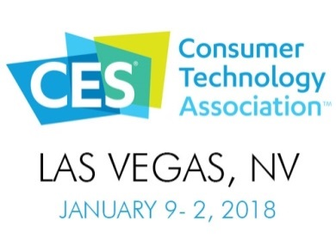

Le CES 2018 approche à grands

Et si on y allait ?

Thanks for filling this form in English since some information will be extracted and published in the CES2018 Auvergne Rhone-Alps brochure and send it to ces2018@minalogic.com before June 30th.

Company:
Contact name:
Contact email:
Contact phone (mobile phone preferred):
Creation year:
2016 Revenues:
2016 Headcount:
Web site:

Company / Product presentation (max 480 characters – spaces included):
Will be included in the brochure.

Company logo: please attach an image file 45 mm / 530 pixels at 300 dpi – no particular format
Product image: please attach an image file 45 mm / 530 pixels at 300 dpi – no particular format

Product unveiled during CES 2018 (max 5 lines):

Targeted Markets:

Primary expectations from attending CES (max two choices – ideally only one):
☐ Technology partnerships identification / meetings
☐ Business development / growth
☐ Venture capitals and investors meetings
☐ Resellers / distributors meetings
☐ Traction and visibility
☐ Techno & competition watch
☐ Other (please specify)

Have you ever exhibited at CES? ☐ Yes ☐ No
If so, when and in which CES zone:
☐ Eureka Park / Eureka Next
☐ Dedicated Markeplace which one:
☐ LVCC

In which zone do you intend to showcase at CES 2018 :
☐ Eureka Park / Eureka Next
☐ Dedicated Markeplace which one:
☐ LVCC
☐ I do not know

Amongst the following preparation sessions, which ones are likely to interest your company?
NB : a detailed presentation of each session will be offered on July 5th during the launch of the CES2018 campaign.

Before CES :
☐ CES introduction – Do’s and Don’ts – Logistics – Preparation sessions presentation – July 5th
☐ Meeting with other delegation members – including multi-attending companies – date TBD – end August / early September
☐ Student support from a Business School (Booth Design, Value Proposition, Pitch…)
(☐ GEM or ☐ EM Lyon)
☐ Innovation Awards
☐ Pitching at CES – November 30th
☐ From Awareness to conversion – October 12th
☐ Crowdfunding – September 14th
☐ Industrialization – November 9^{h}
☐ US export rules (temporary exportation, customs, …) & installation – date TBD – October
☐ Press conference – date TBD – end November
In addition to the above, a delegation Brochure grouping every exhibiting companies will be produced and widely distributed, as well as common press relations (social networks, press releases)

During CES :
☐ CES Unveiled
☐ Large Corporations meetings
☐ Student support for a Business School (Booth Duty)
(☐ GEM or ☐ EM Lyon or ☐ Nevada State University)

Post CES :
☐ Student support for a Business School (Contact qualification & follow-up)
(☐ GEM or ☐ EM Lyon)
In addition to the above, a debriefing session will be organized by the Region to capitalize on CES2018 and prepare the next session.

